**How to open Service request in MS GUI**

**Step 1:** Copy and paste URL link in Browser.

<http://efmsms.it.att.com:8008/ms>

**Step 2:** Enter user ATTUID and Password in box as shown in image below.

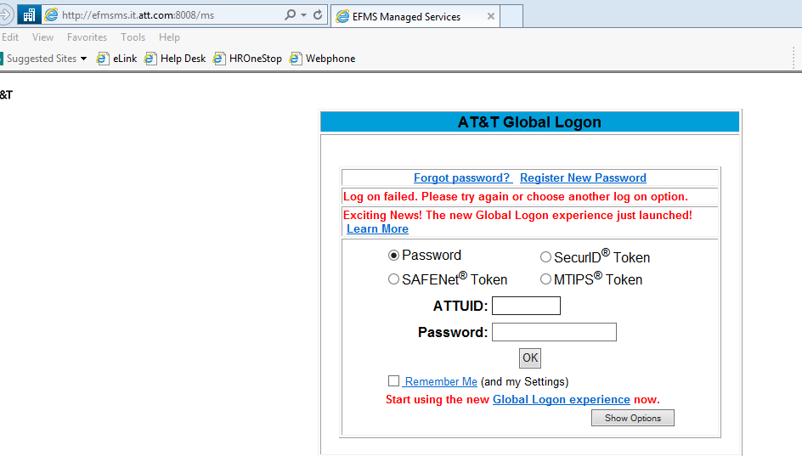

**Step 3:** After entering ATTUID and password in box, press OK button 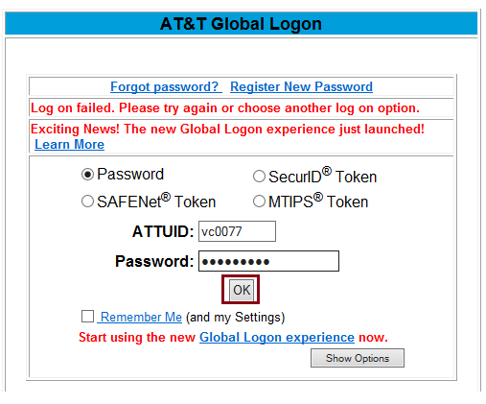

**Step 4:** Front interface of MS GUI will be displayed as shown in below image.

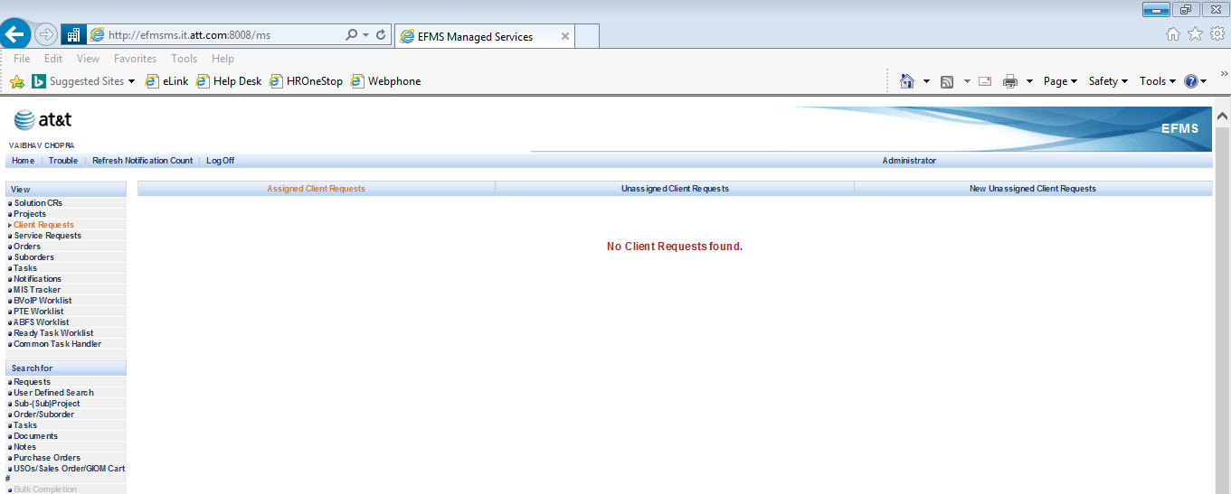

**Step 5:** Click on **User Defined Search**.

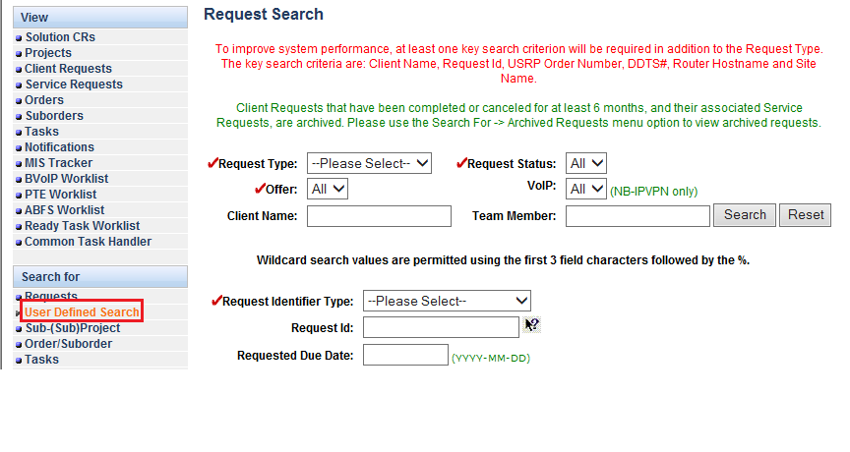

**Step 6:** Click on Request Type option and select **Service Request** option from bar.

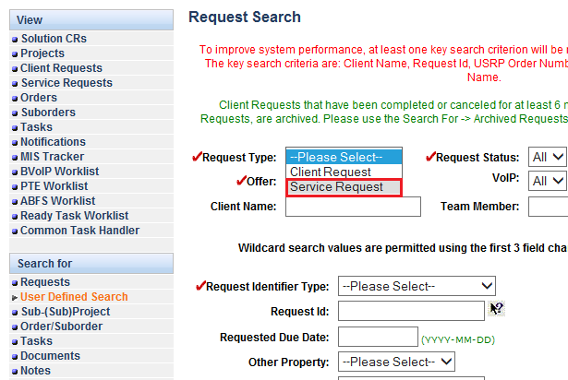

**Step 7:** Write service request ID no. in **Request Id bar**.

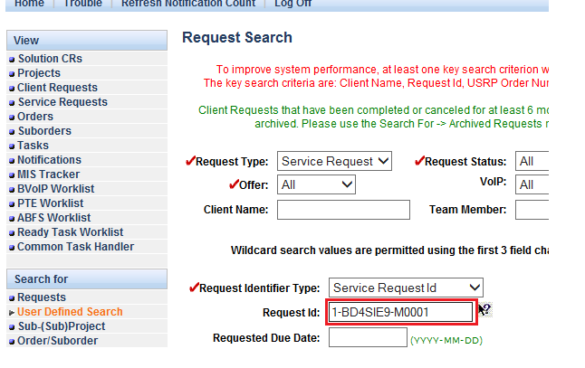

**Step 8**: Click on **Find Requests** tab to open Service request ID.

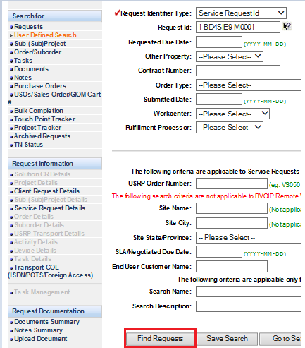

**Step 9:** Service request search results will be displayed, click on **open** tab after tick the box to open service request id.

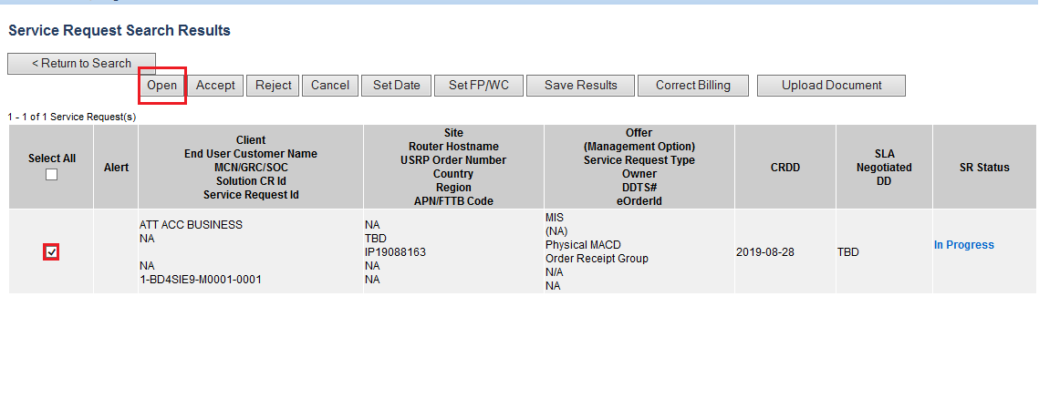

**Step 10:** Service request ID will be displayed with all tabs and information.

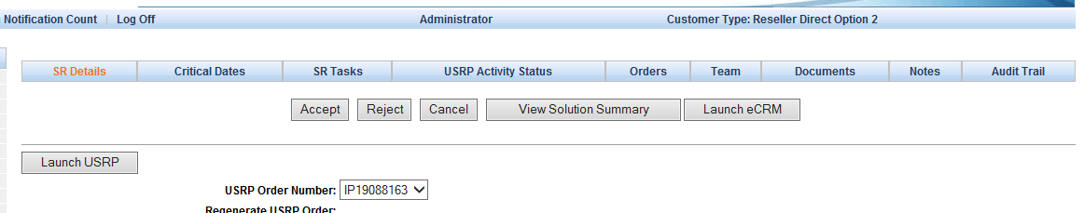

1. **Transport Delivery Task :**

* Login to the **EFMS-MS** application. Select **USER DEFINED SEARCH** option from the **SEARCH FOR** panel on the left side of the home screen. This page would contain the **REQUEST** **TYPE** option.
* Select **SERVICE REQUEST** from the drop down menu as the **REQUEST TYPE**. Once it is selected, the other options on the page would also load. Type in **VS1408366** as the **USRP ORDER NUMBER** and hit enter.
* From the service request search results page, mark the radio button and click on the **OPEN**
* Go to the **USRP ACTIVITY STATUS** and note the **DD completed** date for Native IP or Frame port

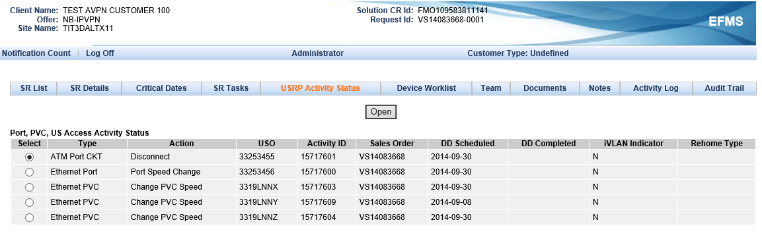

* Go back to the service request search results page (press back space twice). Mark the radio button and click on the **SET DATE**.

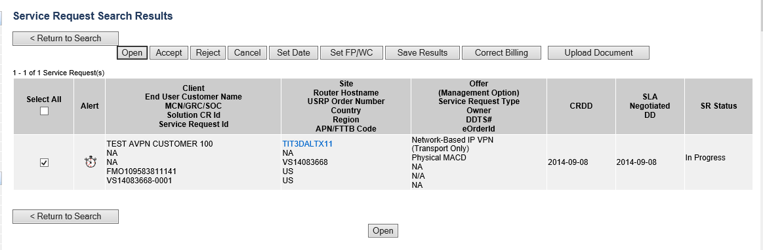

* Paste in the **DD completed** date in the **BILLING EFFECTIVE DATE** text box and hit **SAVE**.

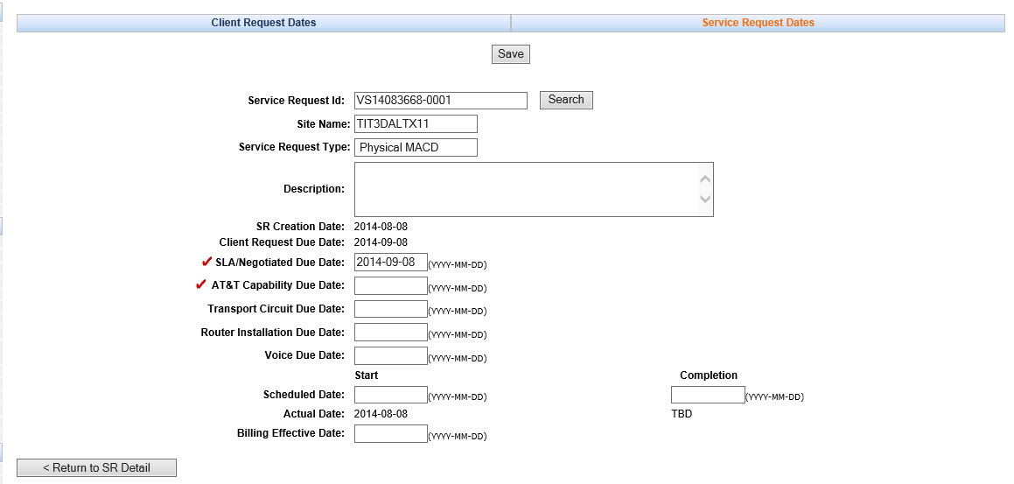

* A confirmation prompt would come up. Hit **OK**.
* From the service request search results page, mark the radio button and hit **OPEN**.
* Select the **TRANSPORT DELIVERY** task from **SR TASKS** panel. Click on **OPEN TASK**.

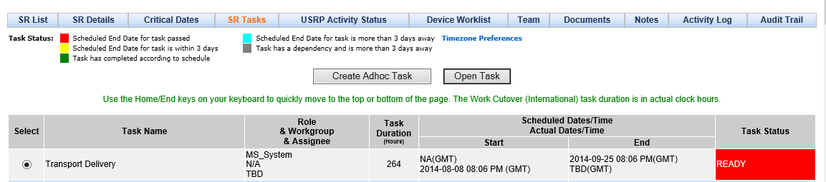

* Hit the **COMPLETE** button on the task details page.

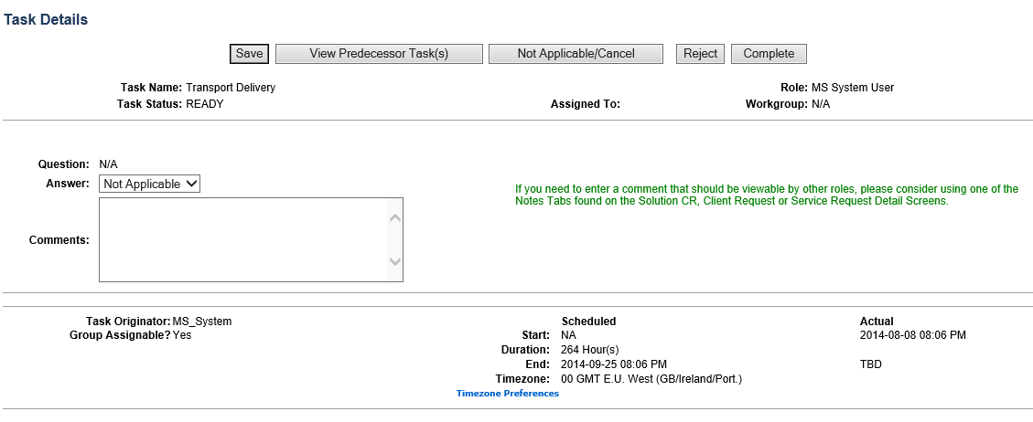

* A **TASK COMPLETION INFORMATION** prompt would come up. Hit **OK**.
* The **SR TASKS** page would load up automatically. The **TRANSPORT DELIVERY** task would have its **SR status** as **COMPLETED** now.